

**ŞİFRE KAYIT ETME VE ŞİFRELEME .NET DESKTOP PROJESİ**

**Geliştirici: Pelin BİNGÖL**

**Proje Danışmanı: Serkan DEVRİM**

This project introduces an application for the purpose of managing user information. The application is designed to manage users' records, registrations and records belonging to specific platforms. C# programming language is used for this purpose.

**Objective**

The purpose of this run is to enable users to easily organize their copies belonging to various online platforms. Users can save information (e.g. username, password, email, etc.) belonging to a specific platform through this application, then search for this information and save it as saved.

**Application Functions**

* Users can collect users in a text file based database.
* Users can use user sections to organize and edit information for a specific platform.
* Users can browse the registered user by platform and other influences.
* If user information is not found on the desired platform, the user is given an appropriate message.
* Users can view the found user through a DataGridView member.
* Users can save data to a text file. If the file does not exist, it is created automatically.

**Technologies Used**

***Programming Language:*** The project is running in Microsoft's C# programming language. C# is an object-oriented language and is often preferred for Windows applications.

***Development Environment:*** The project ranges from a popular development environment such as Visual Studio. Visual Studio offers comprehensive tools for the release of C#.

**Guide**

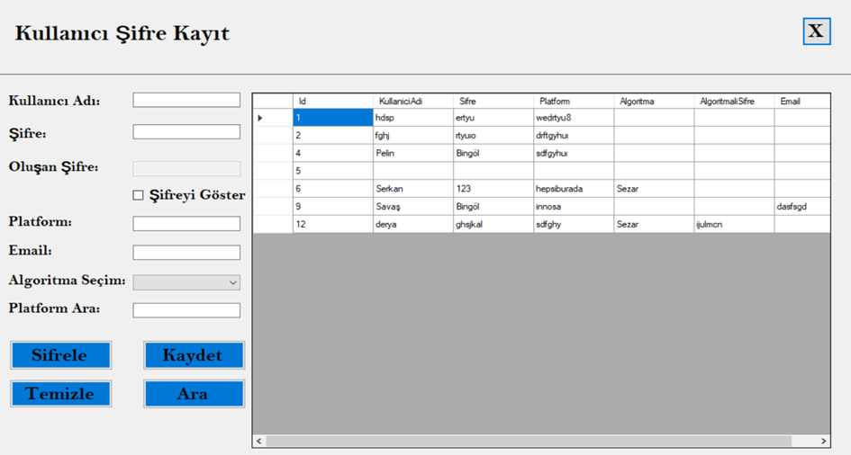

* When we enter the application, this screen will welcome us and we will fill in the relevant boxes.
* When we click on the "*Sifrele*" button in line with the algorithm we have selected from the "*Algorithm Selection*" section, it algorithmizes the password you enter according to the selected algorithm and writes it in the password box. When we click the Save button, it saves the data. It shows it in the table.

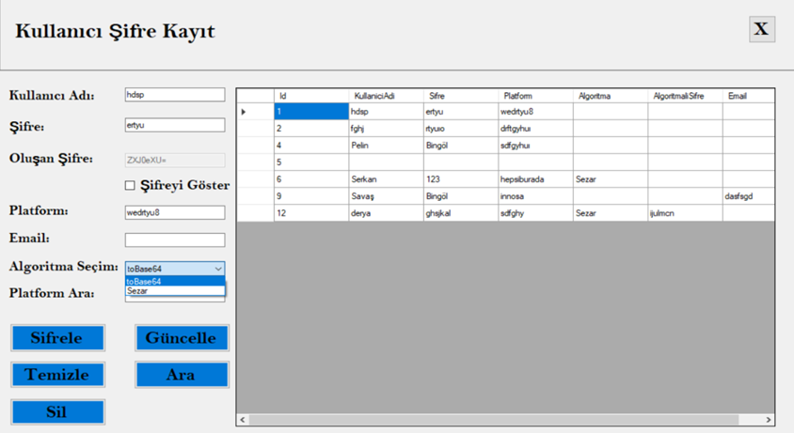

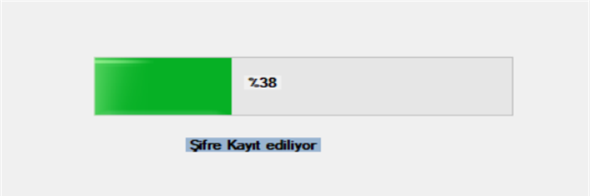

* When we click on the "*Clear*" button, it clears the boxes.
* When we click the "*Search*" button according to the platform name we wrote in the "*Search Platform*" box, it shows the relevant records in the table.

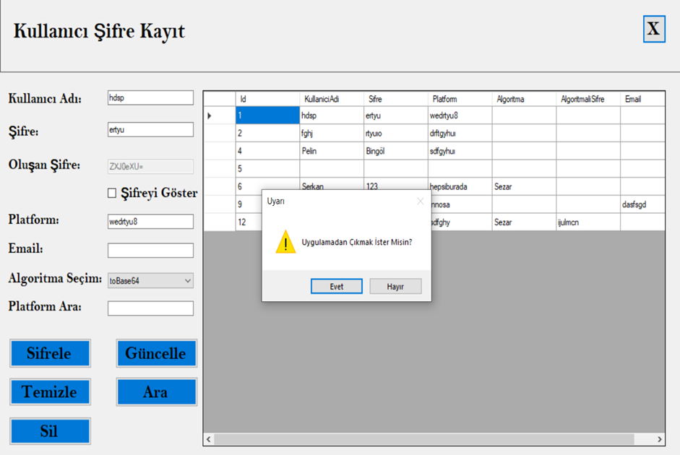

* If we click on the "*Delete*" button, the relevant data is deleted. It is shown in the table.
* When we click on the "*X*" button, the message "*Do you want to exit the application?*" appears on the screen. If we press the "*Yes*" box, we exit the application. If we press "*No*", we return to the application.